Qstn1

<?php

 function printNumbers($n) {

*if* ($n >= 1) {

      echo $n . "<br>";

      printNumbers($n - 1);

    }

  }

  printNumbers(10);

?>

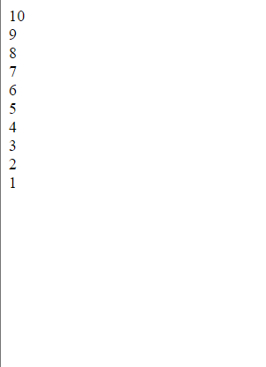Output;

Qstn2;

<?php

setcookie("nafih", "Hello Nafih zain", time() + 3600);

function checkLogin() {

*if* (isset($_COOKIE["nafih"]) && $_COOKIE["nafih"] !== "") {

    echo "User logged in.";

  } *else* {

    echo "User not logged in.";

  }

}

checkLogin();

?>

Output;

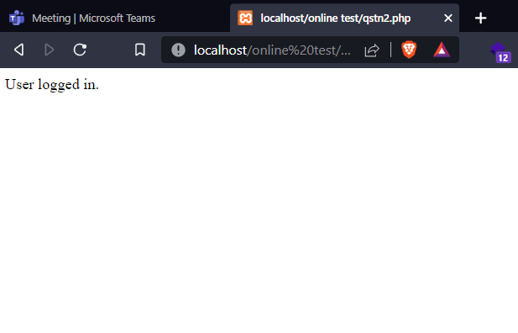

Qstn3;

<?php

$Bikes = array("bmw " =>50,);

*foreach* ($Bikes as $name => $models) {

    echo "<h2 style=color:red;>Brand:</h2> <h3 style=color:blue;>$name</h2><h2>Price in lakh:</h2> $models&#8377 <br>";

}

?>

Output;

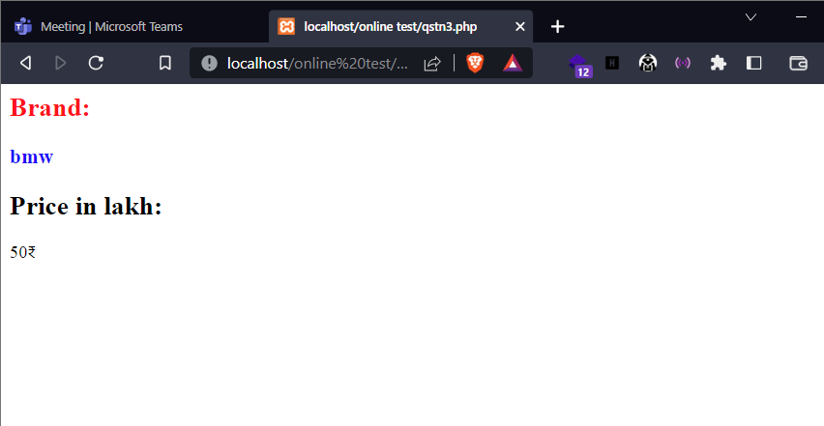

Qstn4;

<?php

$folder = 'C:\xampp\htdocs';

$files = scandir($folder);

echo "<h2 style=color:green;>readed files from $folder</h2>";

*foreach* ($files as $a) {

*if* (!is_dir($a))

    {

        echo "<i>$a</i>" . "<br>";

    }

}

?>

Ouptut;

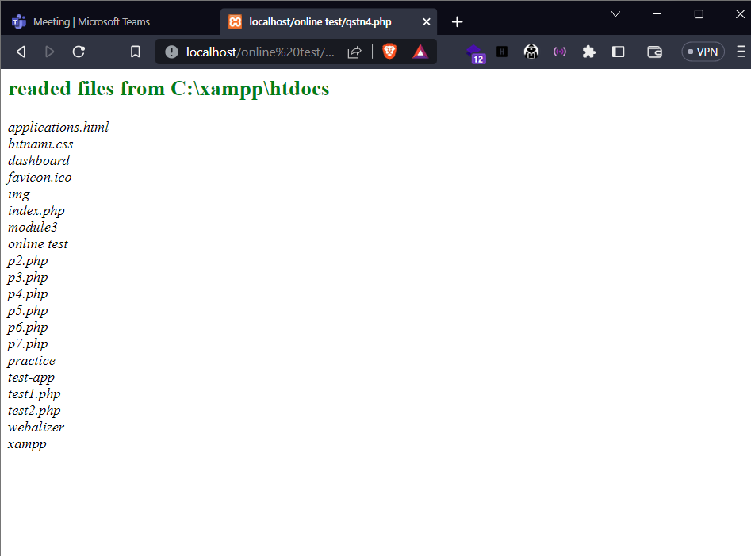

Qstn5;

<?php

$currentDir = __DIR__;

$filename = __FILE__;

$lineNumber = __LINE__;

echo "<b>Current Directory: </b>" . $currentDir . "<br>";

echo "<b>Filename:</b>" . $filename . "<br>";

echo "<b>Line Number:</b> " . $lineNumber . "<br>";

?>

Output;

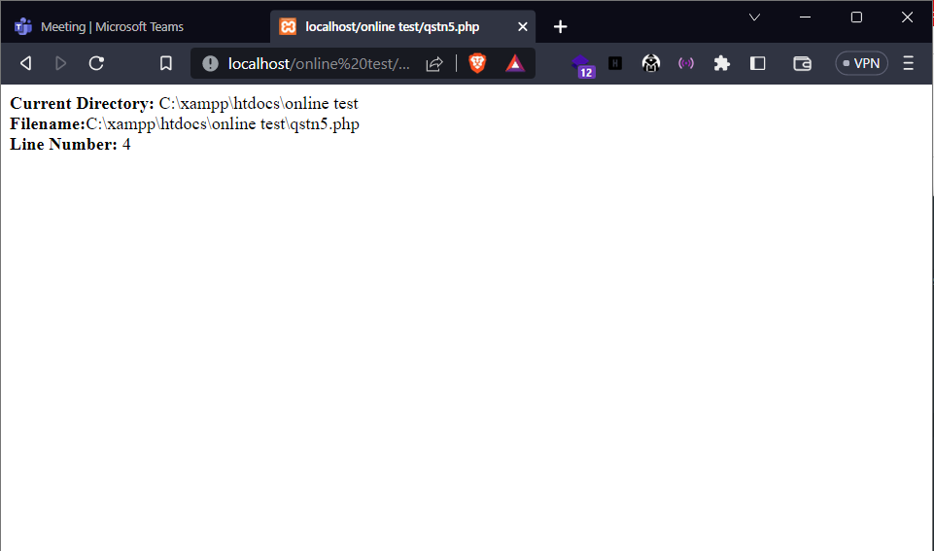

Qstn6;

<!DOCTYPE html>

<html lang="en">

<head>

    <meta charset="UTF-8">

    <meta http-equiv="X-UA-Compatible" content="IE=edge">

    <meta name="viewport" content="width=device-width, initial-scale=1.0">

    <title>Document</title>

    <style>body{

         background-color:#333;

         color:white;

    }</style>

</head>

<body>

    <fieldset>

    <?php

    $a = 10;

    $b = 20;

    echo "Before swapping: <br>";

    echo "a = " . $a . "<br>";

    echo "b = " . $b . "<br>";

    echo "<hr>";

    $temp = $a;

    $a = $b;

    $b = $temp;

    echo "<br>After swapping: <br>";

    echo "a = " . $a . "<br>";

    echo "b = " . $b . "<br>";

    ?>

    </fieldset>

</body>

</html>

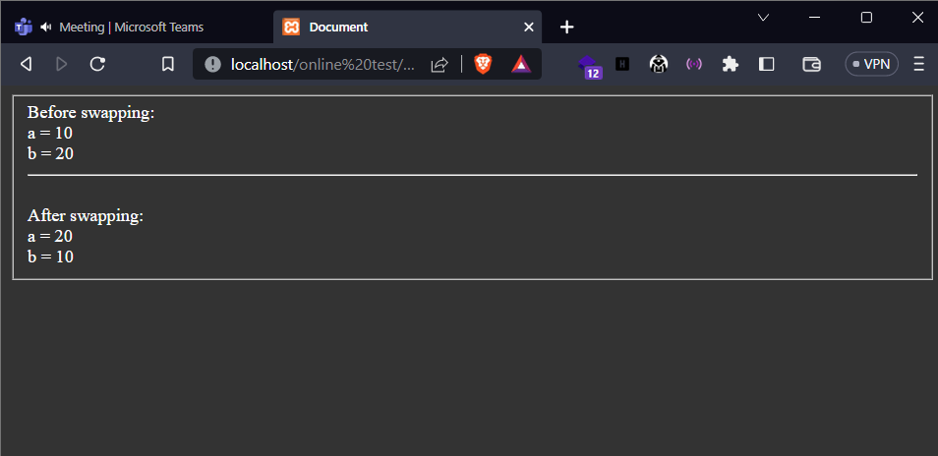

Output;

Qstn7;

<?php

function insertItemInArray($array, $item, $position) {

*if* ($position >= 0 && $position <= count($array)) {

        array_splice($array, $position, 0, $item);

    }

*return* $array;

}

$originalArray = [1, 2, 3, 4, 5];

$newItem = 10;

$insertPosition = 2;

$resultArray = insertItemInArray($originalArray, $newItem, $insertPosition);

echo "Original Array: " . implode(", ", $originalArray) . "<br>";

echo "New Array: " . implode(", ", $resultArray) . "<br>";

?>

Output;

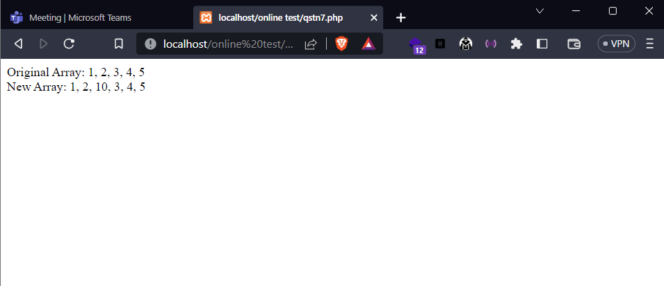

Qstn8;

<!DOCTYPE html>

<html>

<head>

    <title>User Name Form</title>

</head>

<body>

    <h2 style="color:blue;">User Form</h2>

    <?php

*if* ($_SERVER["REQUEST_METHOD"] == "POST") {

        $name = $_POST["name"];

        echo "<p>Hello , " . $name . "! hows your exam </p>";

    }

    ?>

    <form method="POST" action="<?php echo $_SERVER["PHP_SELF"]; ?>">

        <label for="name"><i>Name:</i></label>

        <input type="text" id="name" name="name" required placeholder="Name here">

        <button type="submit">Submit</button>

    </form>

</body>

</html>

Output;

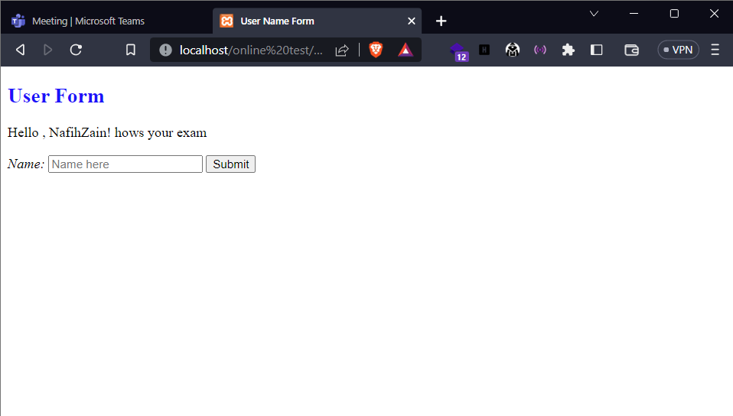

Qstn9;

<?php

function sumOfDigits($number) {

    $sum = 0;

*while* ($number > 0) {

        $digit = $number % 10;

        $sum += $digit;

        $number = (int) ($number / 10);

    }

*return* $sum;

}

$number = 12345;

$sum = sumOfDigits($number);

echo "Number: " . $number . "<br>";

echo "Sum of Digits: " . $sum . "<br>";

?>

Output;

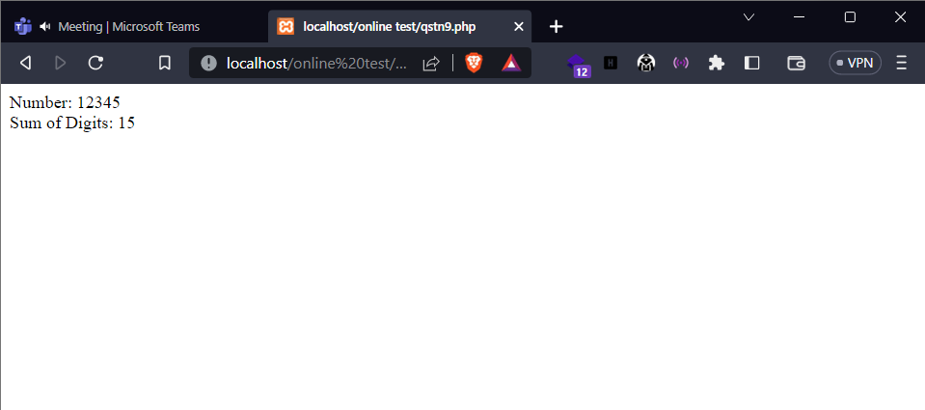

Qstn 10;

<?php

function fibonacci($n) {

    $fibSeries = [0, 1];

*for* ($i = 2; $i < $n; $i++) {

        $fibSeries[] = $fibSeries[$i - 1] + $fibSeries[$i - 2];

    }

*return* $fibSeries;

}

$number = 10;

$fibonacciSeries = fibonacci($number);

echo "Fibonacci Series: " . implode(", ", $fibonacciSeries) . "<br>";

?>

Output;

